**Background:**

* + We need a Suite Installer for different suite
    1. Helpdesk Administrator
    2. Standard Administrator
    3. Enterprise Administrator
  + Each suite carries different features

### Helpdesk Administrator

|  |  |
| --- | --- |
| **If the user chose this** | **Start this installer** |
| AD Users and Computers property page extension | CentrifyDC_AdminExtensions-5.0.0-winXX.exe |
| PuTTY | Putty-3.0.7-736.msi |

### Standard Administrator

|  |  |
| --- | --- |
| **If the user chose this** | **Start this installer** |
| AD Users and Computers property page extension | CentrifyDC_AdminExtensions-5.0.0-winXX.exe |
| Centrify DirectControl Administrator Console  (including NIS map extension, zone conversion and documentation) | CentrifyDC_Console-5.0.0-winXX.exe |
| Password Synchronization extension | CentrifyDC_PasswordSync-5.0.0-winXX.exe |
| DirectManage Download Manager | CentrifyDM-2.0.0-winXX.exe |
| Centrify Zone Provisioning Agent | Centrify_Zpa-5.0.0-winXX.exe |
| PuTTY | Putty-3.0.7-736.msi |

### Enterprise Administrator

|  |  |
| --- | --- |
| **If the user chose this** | **Start this installer** |
| AD Users and Computers property page extension | CentrifyDC_AdminExtensions-5.0.0-winXX.exe |
| Centrify DirectControl Administrator Console  (including NIS map extension, zone conversion and documentation) | CentrifyDC_Console-5.0.0-winXX.exe |
| Password Synchronization extension | CentrifyDC_PasswordSync-5.0.0-winXX.exe |
| Centrify DirectAudit (all components) | Unzip CentrifyDA-1.3.0.win.zip into a temporary directory and run setup.exe |
| DirectManage Download Manager | CentrifyDM-2.0.0-winXX.exe |
| Centrify Zone Provisioning Agent | Centrify_Zpa-5.0.0-winXX.exe |
| PuTTY | Putty-3.0.7-736.msi |

**Suite Installer 2012 Flow**

1. Check for feature existence
   * Check the file existence against InstallConfig.xml
     1. If all features of a suite exist, this suite is available.
   * Check for installed features
     1. For a valid suite, check each feature in registry, if it’s already installed, its product code is stored in registry HKLM\Software\Classes\Installer\Product\<guid>
     2. If the product code exist, check the installed version under the same registry key
     3. If any feature of version 3.x or 4.x is already installed, show a dialog to tell the customer to uninstall it first, then proceed to Step 2 **Welcome Page**
     4. If any feature of the same version 5.0.0 is already installed, proceed to Step 3 **Maintenance Page**
        1. Putty version is 3.0.7
2. Welcome Page

The Welcome page is a generic Wizard welcome page.



Now go to step 4 **License Agreement Page**

1. Maintenance Page

If started to modify / change the installation show the Wizard page below to give the user the following options:  
- Reinstall previously chosen components: go to step 11  
- Add or remove Centrify Suite components: go to step 5  
- Uninstall: go to step 15



1. License Agreement Page

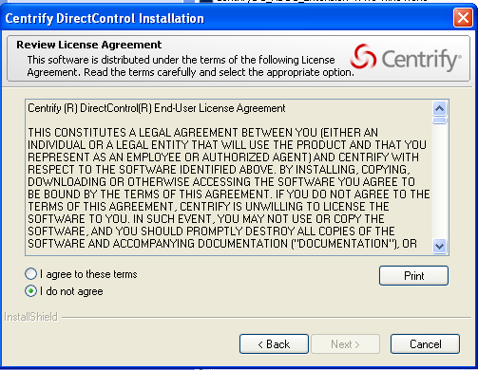

Next button is enabled only if “I agree to these terms” is checked.User Registration

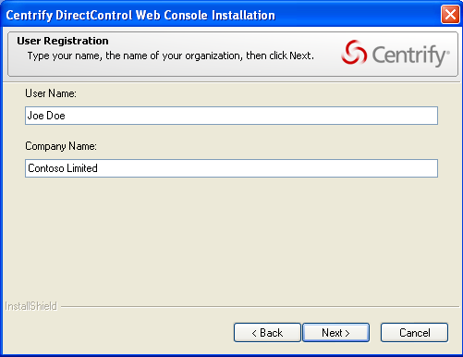

Next button is enabled only if both user name and company name are not blank.

1. Suite Type

* In step 1, you should have checked which of the Suite is available. Only enable those suites with all features available.
* For maintenance mode, the default selection is the installed Suite type (check HKLM\Software\Centrify\Cims\SuiteInstaller\SuiteType)



1. Features

* Depends on the select suite in Step 6, fill the features list according to InstallConfig.xml.
  + For new install, all features are checked by default, go to step 8
  + For maintenance, only installed features are checked (this is checked in step 1), skip step 8

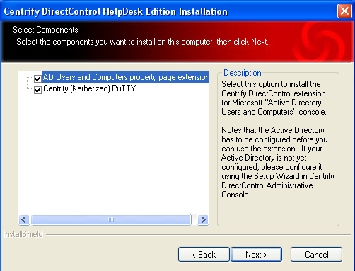

1. Install Directory

This dialog allows the user to choose the base path for Suite installation. Individual components are installed in directories below this, for example:

*C:\Program Files\Centrify\DirectControl*



1. DC Console – Disable Publisher Evidence Verification

if this installation installs DirectControl Administrator Console, show this screen.

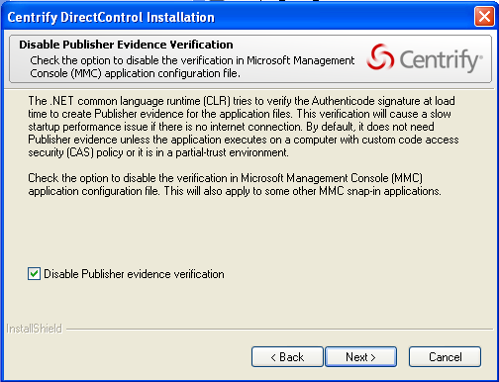

1. Web Console – Virtual Directory

If this installation intsalls DirectControl Web Console, show this screen.

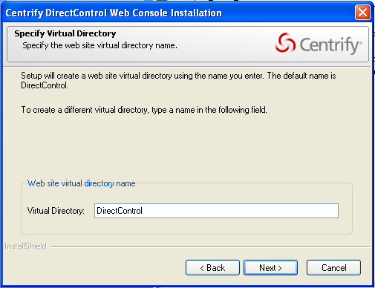

1. DA 1.3 – Install Type (Quick Install vs. Server vs. Workstatoin vs. Custom)

If this installation installs DirectAudit, show this screen

1. Confirmation page  
   This is a standard install Wizard confirmation page, where the user is presented with a list of the choices they have made prior to installation starting. In this case the list contains only those choices made in the component choice page.

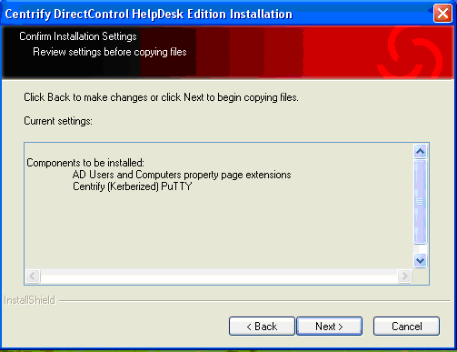

1. Installation Progress page

This page shows the progress of the install, package by package. The installer now **synchronously** starts the installer for each package in turn, based on the choices from the component choice page (read **InstallShield Silent Install** below, which show the steps to do silent install).

The internal silent install logic is as below

1. According to the collected user input, generate the answer file to the %temp% directory
2. execute silent install with the generated answer file at %temp% directory

Each package installer (except DirectAudit 1.3.0) is launched in silent install mode so that no Wizard is run.   
  
The return code from each installer should be checked, so that errors during installation can be recognized. If an error is detected, the user should be given the option of continuing the installation or exiting.

1. Configuration Page

If DirectControl Web Console is selected and installed successfully, show this screen

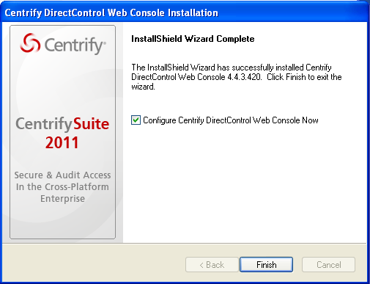

The **Finish** button here should say **Next**

1. Finish Page

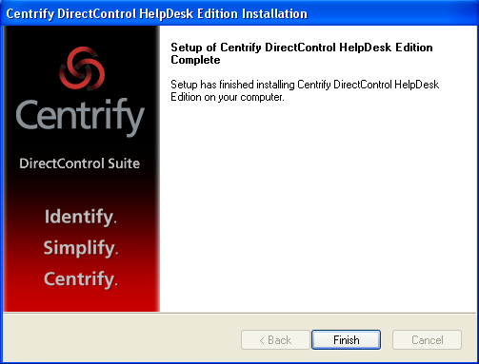

Standard installation Wizard completion page (see below).  
  
If errors were returned by any of the installers then the following additional text should be displayed, below the text in the example screenshot:  
  
“One or more errors were encountered during installation, you may need to correct these errors and run the installation Wizard again.”

1. Uninstall  
   Alert: “Are you sure you want to completely uninstall Centrify Suite? Click Next to uninstall the Suite or Cancel to Quit.”  
     
   If the user chooses “Yes” then uninstall all components.  
   If the user chooses “No” then go back to step 3.

**Suite Installer Registry**

Create the key HKLM\Software\Centrify\Cims\SuiteInstaller

Store SuiteType as DWORD

Version as DWORD

InstallPath as string

**InstallSheild Silent Install**

1. How to perform silent install with setup.exe?

Assume the answer file is stored at c:\temp\answer.txt

To generate a silent install answer file, run this command

> Setup.exe -r -f1”c:\temp\answer.iss”

**\* note: .iss stand for “InstallShield Silent”, which is the technology named by InstallShield**

To perform a silent install with answer file, run this command

> Setup.exe -s -f1”c:\temp\answer.iss” -f2”c:\temp\setup.log” -v”/qn /l* c:\temp\msiexec.log”

To perform a silent install of a particular feature with answer file, run this command

> Setup.exe -s -f1”c:\temp\answer.iss” -f2”c:\temp\setup.log” -v”/qn /l* c:\temp\msiexec.log ADDLOCAL=<feature-name>”

1. How to perform silent install with msi file (putty uses msi)?

msiexec /i putty.msi /qn /l* c:\temp\msiexec.log USERNAME=joe.doe COMPANYNAME=”wesoft” INSTALLDIR=”c:\program files\xxxx”

1. How to support silent install using **Install Script**?

Check the global variable MODE is SILENTMODE to determine if it is a silent install.

DirectControl Administrator Console

1. Fix it to use SdMakeName and SilentWriteData so when running setup.exe /r the “disable publisher evidence verification” is exposed to the answer file

Our current installer generate it into answer file as

[{A426E98C-33B4-45CD-9626-5E1254613E96}-AskOptions-0]

Result=1

Sel-0=1

**This task is optional; we can name it with a better variable name with SilentWriteData**

DirectControl Web Console

1. Fix it to use SdMakeName and SilentWriteData so when running setup.exe /r the “Virtual Directory” is exposed to answer file.
2. Fix it to use SilentReadData to perform silent install
   1. Fix SdVirtualDirectoryDlg(), do not call WaitOnDialog for silent install
3. Using Argument Approach for individual feature installation

Do the same as our old Suite Installer, e.g. by passing BADUC to tell if we should install ADUC feature within DC installer.

**Suite Installer .Net project**

1. This can be done with .Net, have to implement the whole **Suite Installer 2012 Flow** section
2. The wizard can either subclass from Cfw.Windows.Wizard or Util.UI.Wizard
3. Use ILMerge to stitch all referenced assmeblies into a single assembly, please refer to the project file at //depot/DA/windows/install/wizard/all/install.wizard.all.csproj, there is a **<AfterBuild>** task which run ILMerge
4. Fix our build script to build this new Suite Installer